# **Executive Summary**

The purpose of this document is to provide an assessment of the level liability risk Crane Co may have relative to its industry peers based on a detailed analysis using data-driven techniques and provide additional industry research to support the findings. As a result, the outcome is to develop recommendations while being aware of the limitations in the analysis. For contextual purposes, the level of liability risk being assessed pertains to a company’s risk of being targeted in a shareholder class action litigation suit, specifically, assessing both the likelihood and potential monetary severity this risk entails.

The structure of this report provides a detailed explanation of:

1. The process used to compile and use the data provided for this analysis
2. A summary of the results and findings obtained
3. Recommendations and limitation based on the results and industry research conducted

As part of the process used to compile and utilize the data, I will provide an overview of how the data is originally provided, and then go through the steps used to prepare the data in a format that is ultimately used for modeling and prediction. The steps to prepare the data focus on both qualitative and quantitative approaches, which include

* Restructuring the dataset to analyze companies on an individual row-by-row basis
* Assessing the columns to use for the analysis
* Cleaning null/ missing values
* Aggregating multiple years-worth of data provide for each company using statistical techniques
* Assessing the overall population and determining an appropriate sampling technique
* Weighting variables to ensure they are scaled appropriately
* Assessing outliers and which of two potential approaches to use for this analysis

Once the data preparation steps have been completed, the modeling is conducted, which is used to provide results and findings. The modeling used in this analysis utilizes logistic regression and consists of running multiple iterations of the model for optimal results. Each iteration consists of:

* Reviewing correlated fields and making decisions on which columns to ultimately include in the model
* Using the most optimal splitting of the dataset
* Assessing the modelled results
* Utilizing confusion matrices and additional metrics to interpret the resulting outputs
* Analyzing and assessing the modeled results
* Assessing the severity this risk poses

Once the iterations are complete, the model evaluations are conducted, which assess the output of each iteration’s initial accuracy score, cross validation mean, precision score, recall score, and F1 score. These metrics help aid in deciding what final model is best to use when assessing the likelihood component of the analysis. Finally, once the likelihood portion of the analysis is completed, additional work to understand the potential severity of what a derivate suit entails is conducted.

Using these findings in conjunction with additional industry research obtained, some final recommendations are provided to the client. The final recommendations consider the following:

* The modelling limitations used to make the assessment
* The likelihood of Crane Co. being suit relative to its peers based on the drivers of a potential suit
* The potential severity the risk a suit will have to the firm if it were to occur

# **Data and Approach**

**Summary**

Before any analysis and modeling can be completed, an approach of how to use the data must be completed, as this is the strategic approach that ultimately creates the story for the overall results of the analysis. The datasets used in these reports consists of two datasets, the fundamentals dataset and the SCA filings and settlements dataset. The fundamentals dataset contains financial data related to publicly traded company’s’ annual 10-k filings, which include any restated filing amounts where applicable. The SCA filings and settlements dataset provide a list of companies that have been named as a defendant in a shareholder class action suit, as well as the amount each company has paid out in damages for a settlement or court determination, where applicable (no payment would be provided if no settlement occurred or if the suit was dismissed by the court).

**Initial Dataset Restructuring**

The first step in data preparation was to restructure the dataset to differentiate amounts stated in a company’s original 10-k filing with the restated amounts (if any). This resulted in the duplication of each numeric column where a restatement could potentially occur. The way in which this was completed was to use the use the ‘*datafmt’* column, where “STD” signifies amounts reported in a company’s originally filed 10-k and “SUMM_STD” signifies amounts reported because of a restated filing. The “STD” and “SUMM_STD” values were added to the prefix of each numeric column to avoid confusion of where the numeric values were derived (e.g., ‘*STD_at’* = total assets associated with an originally filed 10-k; *‘SUMM_STD_at’* = total assets associated with a restated filing). The original dataset consisted of 3,974 rows and ultimately was reduced to 2,057, which highlighted that 1,917 of the rows were associated with a re-stated filing. As a final step to this first step, a ‘*restatementflag*’ column was generated for 1,917 of the final 2,057 columns to identify when company have some sort of restatement occur for a given quarter.

**Assessing the Columns to Use**

One of the strategic paths of this analysis was to filter out any columns in which a restatement amount was never filed. The result of filtering out the use of these columns is to isolate the potential association between 10-k restatements and shareholder class actions suits filed. As a result, of the 900 plus columns, 32 columns showed to have had a restated amounts occur within this sample of company filings. The 32 columns included very key financial values, such as net income, cost of goods sold, sales, total assets, total equities, etc. In addition to these columns, some other key financial columns not related to restatements were used.

After narrowing down the initial key financial values to use within the analysis, some additional columns were manually generated to potentially create additional value, which include:

* Suitflag – this column is a result of joining the SCA filings and settlements dataset to the fundamentals by using the tic key; put simply, a value of 1 and 0 are stated was or was not provided on the filings and settlements dataset, respectively
* Roa – financial ratio created for return on assets, which is the net income divided into total assets
* Roa – financial ratio created for return on equity, which is the net income divided into total equity
* Dte – financial ratio created for debt-to-equity, which assesses the level of debt to total equity

It is important to note that by assessing these columns for use removed the need to do an extensive review of which columns should be removed due to being primarily null and not useful. However, a null review for missing values was completed with only two rows showing as nulls. These two rows were removed, as they did not materially alter the overall results of the analysis.

**Aggregation of Multi-Year Reporting Data**

The next step in the analysis is to take a quantitative approach by determining the values that potentially get used in the model run. When determining the values used, it is important to first consider what the overall goal of this analysis is. Secondly, as the data provided contains multiple years’ worth of 10-k filings, it is important to consider what technique makes sense when converting the data to display each company within their own individual row. Considering the overall goal to determine what fields are most likely to trigger a shareholder class action suit, two questions come to mind:

* How volatile are the variances between the originally stated values and the restated values for each company over time?
* How volatile are the financially reported values for each company over time?

To understand how volatile the variances are between the originally stated values and the restated values, I took the following approach:

1. Subtract the originally stated value from the restated value to obtain the variance
2. Isolate out the minimum variance to a temporary dataset for each company over their respective years in which 10-k financials were reported in this dataset
3. Isolate out the maximum variance to a temporary dataset for each company over their respective years in which 10-k financials were reported in this dataset
4. Take the greater of the absolute value of the minimum and maximum values between the two datasets and use that value in a newly created ‘Variance’ column for each numeric value.

It is important to note that these variance values only apply to the numeric columns that had restated values occur. For instance, within this dataset, no restated values occurred for ‘*Inventory – Total*’ (invt), so there would be no variance occur.

By taking this approach, the major extreme swings in values are captured amongst each of the companies and isolate out a comparison metric when determining if Crane Co. may be more or less of a risk than its peers and competitors.

The second question specifically addresses assessing the volatility in the values reported by each company over time. This takes the financial values reported in all the years available for each company and calculates the standard deviation. Again, by focusing on significant swings amongst the reported values signifies a potential growth or stress to the firm and can be a potential indicator for if a shareholder suit is filed.

Some other tactics were taken but ultimately not used in the final model runs. For example, the mean reported values for each company over time were taken using the same approach in the second question. However, the mean for each column was extremely correlated with the standard deviation values generated so were ultimately filtered out of the analysis prior to running the model. Another tactic used was to take the most recently filed values for each company. However, these values did not trigger significantly relevant results when attempting the model run, so were also not used in the final model runs.

**Assessing the Overall Population and Obtaining a Sample**

At this point, the dataset has been transformed to contain each individual company on a row-by-row basis with the relevant categorical and numeric variables included. The next steps are to step back and ask the following questions:

**Figure 1**: Percent of companies who have had a suit filed against them

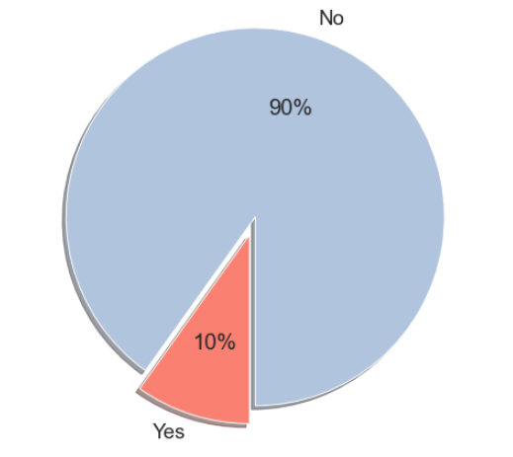

* What percent of the total population has a suit been filed?
* Is the existing ratio of companies in which a suit has been filed to the entire population sufficient to be able for a predictive or analytic model to achieve an outcome that provides insight and aids in the support of the overall goal of this analysis.

The visual to the right displays the answer to the first question, which indicates that only 10% (57) of the 578 companies have had a shareholder suit filed against them during the time provided from the datasets used for this analysis.

Based on the size of the population (578) and only 10% of companies having had a suit filed, this is too low to provide a sufficient predictive analysis, so two steps were taken to help achieve this. The steps taken include:

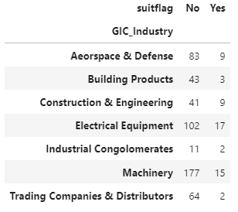

**Figure 2**: Number of companies with a suit filed by GIC Industry

1. Reviewing the distribution of companies in which a suit was filed by GIC Industry to potentially filter out un-related industries
2. Taking a random sample of the remaining companies to remove any bias from the total population

After reviewing the GIC industries, which is also provide to the right in Figure 2, it was determined that it was suitable to filter out the following two industries: Trading Companies & Distributors and Building Products. This resulted in reducing the overall population to 471 companies.

**Figure 3**: Percent of companies who have had a suit filed against them

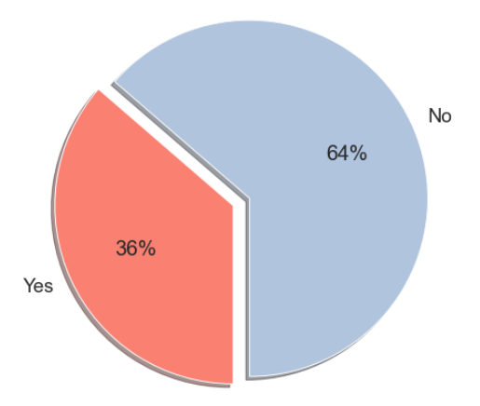

The next step is to take a random sample of the remaining companies to remove bias from the companies within the remaining industries, so 90 companies were selected at random, resulting in a new distribution of companies who have a had a suit filed against them, which is displayed to the left in Figure 3.

Now that a suitable sample has been selected, the next steps are to assess the quantitative data by weighting the variables to be scaled appropriately for the model run and assessing what actions need to be taken for the outliers that are present.

**Weighting Variables**

The scale for the numeric values is a very important consideration for this analysis for a couple reasons. With the sample size being relatively small and the potential for significant differences in values amongst many different numeric continuous variables, it is important to weight the variables to an “apples to apples” comparison. This is completed, simply by the following formula for each column:

Z-score = Absolute Value( (Variable – Variable Mean) / Variable Standard Deviation )

Each variable has now been converted to its relative Z-score, which specifically values each variable by how many standard deviations it is from its relative mean. For example, if the *‘Vol_roe_variance’* (calculated roe variance of originally stated and restated roe) equals 1, then this number is 1 standard deviation from the entire variable’s mean.

This weighting technique helps with a couple things. It helps by reducing the significant swings between companies that may have substantially different values, which could ultimately impact the outlier analysis and filter out key companies that would help with the overall modeling. It also helps play a role in how the variables will interact and correlate when running the model.

**Outlier Detection**

The final step before beginning the modeling portion of this analysis is to detect the existing outliers and decide what steps to take. Since the variables have been weighted using z-scores and are converted to how many standard deviations they are away from their respective mean, the first step in detecting the outliers is to isolate any values greater than 3 standard deviations from the mean. Once detected, two options are considered, which include:

1. Filtering the outliers from the sample where greater than 3 standard deviations from the mean
2. Capping the max z-score at 3, converting any value greater than 3 to equal 3

The option chosen for this analysis was to cap the z-score to a maximum of 3 for two reasons. First, by capping the value, additional features from the company with an outlier may provide value and be relevant to the modeled results. Second, it would further reduce the sample, making the model potentially less reliable. These final steps conclude the initial approaches to transform the dataset for the model runs in the upcoming section. It is important to note that *‘gvkey’* column is how the modeled results and prediction outcomes will be traced back to the original dataset when final model interpretations are reviewed.

# **Detailed Findings**

**Summary**

In this section, I will highlight some steps taken during the modeling process, which include:

* Analyzing binary and multi-value variables
* Assessing correlations amongst the variables
* Assessing the modeled results for each iteration of the model ran, which include providing the results of the confusion matrix
* Evaluating and choosing the best model
* Interpreting the results of the model chosen
* Reviewing the overall potential severity impact

The modeling technique used for this analysis is logistic regression. Since the goal is to predict what variables are driving the potential for a shareholders class-action suit (0 = no, 1 = yes), choosing logistic regression as the model was an ideal choice. In the upcoming sections, the required model preparation work will be discussed, the model iterations results review, and what the overall results mean and indicate for Crane Co.

**Binary and Multi-Value Variables**

The first step in preparing the data for the model is to ensure the binary and multi-value columns are converted to values that the model can interpret. All binary columns are converted to a format where the value is either 0 or 1. Dummy variables will be generated for the multi-value columns. Below is a table summarizing the results of the binary and multi-value columns review.

|  |  |
| --- | --- |
| **Column** | **Notes** |
| **Binary:** |  |
| idbflag | D = ‘Domestic’ converted to 0  B = ‘Both’ converted to 1 |
| Restatement Flag | 1 = ‘Yes’; 0 = ‘No’ |
| **Multi-Value** |  |
| GIC_Sub_Industry | Newly created columns:  'GIC_Industry_Aerospace & Defense' **  'GIC_Industry_Industrial Conglomerates'  'GIC_Industry_Construction & Farm Machinery & Heavy Trucks'  'GIC_Industry_Electrical Components & Equipment' 'Industrial Machinery'  'GIC_Industry_Heavy Electrical Equipment' 'Construction & Engineering'  'GIC_Industry_Agricultural & Farm Machinery'  **Removed due to logistic regression requirement to drop at least 1 dummy variable |
| GIC_Industry | Removed and not used due to direct correlation to GIC_Sub_Industry column |

**Review Data Correlations**

The next step in the pre-modeling process is to review the variable correlations and remove any variable with a correlation greater than 82%. The purpose of removing the correlated variables is to prevent poor model performance. When assessing the highly correlated variables, there were several variables that had a significant correlation and were removed from the analysis (see *Appendix A – Initial Correlation Plot* for overview of results).

**Running the Model – Multiple Iterations**

The overall objective of the model is to predict if a company is to have a shareholder class action suit filed using the *‘suitflag’* field as the binary indicator.

On the upcoming pages are the diagnostic plots and table of significant variables identified through each model iteration. The logistic regression model was run multiple times to ensure the most proper fit of the model was used.

Below is diagnostic plot of the initial model run, as well as a table of the significant variables identified:

**Figure 4**: Initial Model Run Results

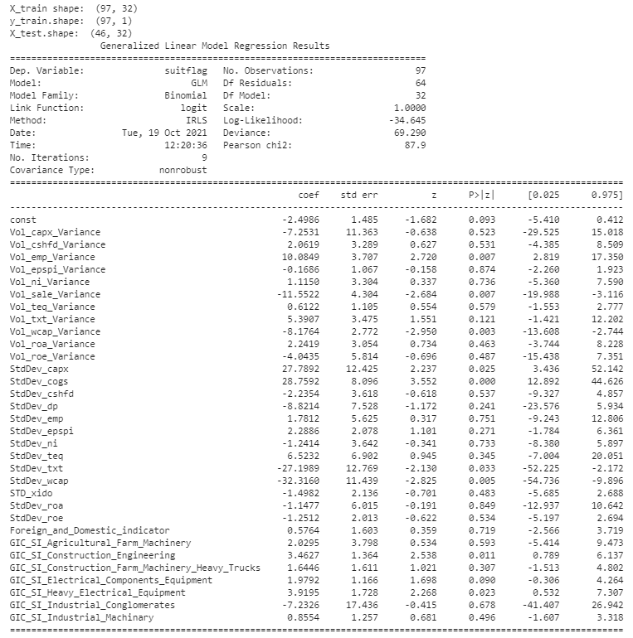

|  |  |
| --- | --- |
| Significant Variables | Description |
| Vol_emp_Variance | Abs value of min or max of the variance between stated and restated number of employees |
| Vol_sale_Variance | Abs value of min or max of the variance between stated and restated total reported sales |
| Vol_wcap_Variance | Abs value of min or max of the variance between stated and restated reported working capital |
| StdDev_capx | Standard Deviation of Working Capital over time for each company |
| StdDev_cogs | Standard Deviation of Working Capital over time for each company |
| StdDev_txt | Standard Deviation of Working Capital over time for each company |
| StdDev_wcap | Standard Deviation of Working Capital over time for each company |
| GIC_SI_Construction_Engineering | Construction and Engineering GIC Subindustry |
| GIC_SI_Heavy_Electrical_Equipment | Heavy Electrical Equipment GIC Subindustry |

Below are the diagnostic plots of the second and third model runs, as well as a table outlining the final identified significant variables.

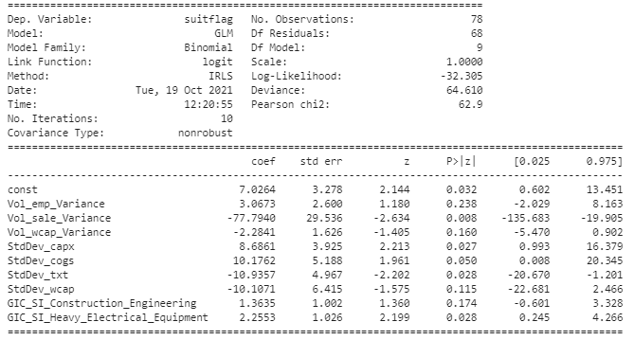

**Figure 5**: Second Model Run Results

|  |  |
| --- | --- |
| Significant Variables | Description |
| Vol_sale_Variance | Abs value of min or max of the variance between originally stated and restated total reported sales |
| StdDev_capx | Standard Deviation of Working Capital over time for each company |
| StdDev_txt | Standard Deviation of Working Capital over time for each company |
| GIC_SI_Heavy_Electrical_Equipment | Heavy Electrical Equipment GIC Subindustry |

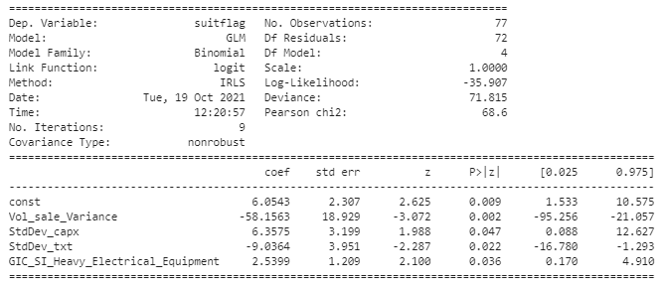

**Figure 6**: Third and Final Model Run Results

**Confusion Matrix Results**

Throughout the process of running the modeling, it is important to consider the predicted results, specifically assessing the portion of the matrix where ‘*Y test’* (y-axis on Figure 5 visuals below) is equal to 1, as this examines if a company will have correctly or incorrectly predicted a shareholder suit to occur for companies within the sample. For the purposes of this report, the number of predictions to be accurately predicted (Y test = 1; Y predict = 1) is likely to be low, as the number of actual suits to the entire population is consistent with a low number of cases throughout the population. Additionally, due to a small sample size, the predictive power of the model is limited. This will be addressed further in the final section of this report under the limitations to consider.

**Figure 5**: Confusion Matrices for Model Run Results

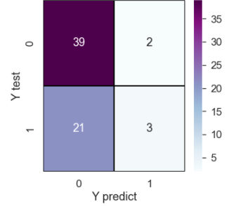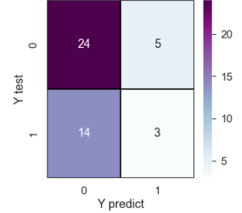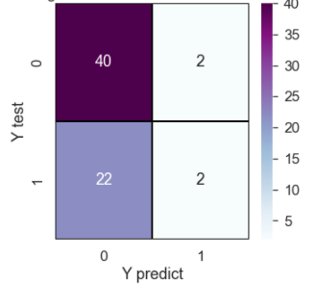

**Initial Model Run Results Second Model Run Results Third Model Run Results**

**Evaluating and Choosing the Best Model**

However, when running the model, it was also important that accurate predictions occur, which leads to credibility into understanding if the model is useful to determining the risk. In addition to reviewing the confusion matrices results, Figure 6 above highlights some additional metrics reviewed when considering which model to ultimately use.

**Figure 6**: Overall Performance Metrics of Each of the Three Model Runs

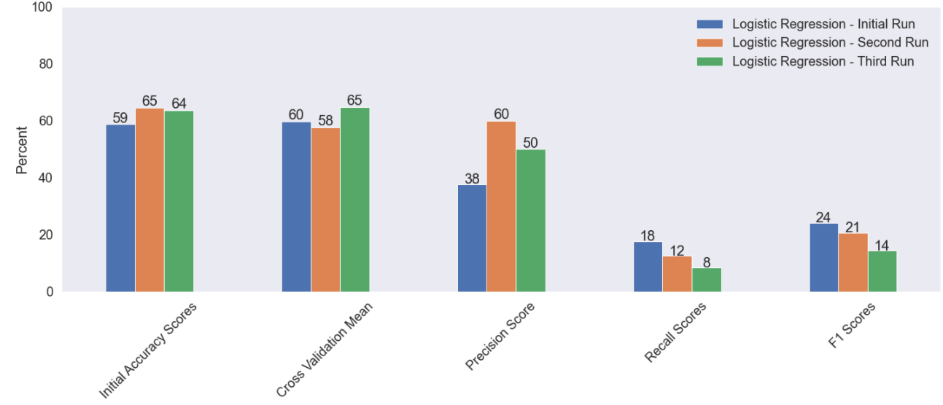

The first three metrics to consider are the initial accuracy scores, cross validation mean, and precision scores, as each of the three are higher from the initial model’s performance. This is important, as it validates the model to not be overfit in the first model run, relying on many variables to predict the overall results. Additionally, however, the recall and F1 scores have somewhat declined since the initial model run. The recall is very important for this analysis specifically, as the recall is the percent companies predicted to have a suit filed against them and it to have occurred. Overall, the recall numbers are not significantly different amongst the three models. Based on these considerations of the overall metrics, using the third model as the model for prediction is what this analysis is moving forward with. In the upcoming section, this analysis will further look at what these results mean and how Crane Co. compares amongst its peers.

**Assessing Modeled Results**

|  |  |
| --- | --- |
| Significant Variables | Description |
| Vol_sale_Variance | Abs value of min or max of the variance between originally stated and restated total reported sales |
| StdDev_capx | Standard Deviation of Working Capital over time for each company |
| StdDev_txt | Standard Deviation of Working Capital over time for each company |
| GIC_SI_Heavy_Electrical_Equipment | Heavy Electrical Equipment GIC Subindustry |

Although there are significant limitations in the modeled results, this assessment’s focus is to gain a better understanding of the potential risk Crane Co. will have a shareholders class action suit occur, not predict that the suit will occur. Based on the modeled results, below are the major factors potentially driving the risk of a shareholder suit occurring amongst Crane Co. and its peers:

Below are summarized assessments of what these variables may mean in relation to the risk being examined.

**Figure 7**: Count of companies where a suit has been filed by GIC Sub Industries

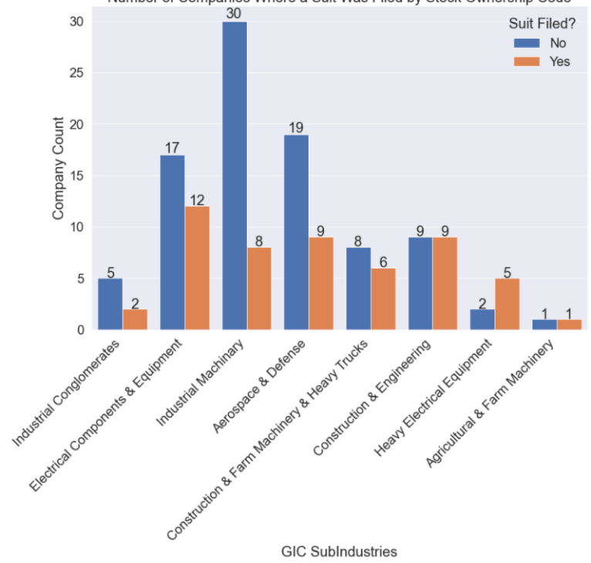

**GIC_SI_Heavy_Electrical_Equipment**

The first variable to consider when assessing the companies in the industry in which a suit has been filed is the Heavy Electrical Equipment and Construction & Engineering sub industries. Both industries were significant in the initial model run and warrant assessing. These are two industries in which would hold some additional scrutiny in this risk assessment. However, since Crane Co. is within the Industrial Machinery sub industry, it looks as if that industry is the least risky according to this analysis.

**Vol_sale_Variance**

Figure 8 below provides some insight into how the volatilities of a reported sales variance may signify a potential shareholders class action suit being filed. Both groups (suitflag = No; suitflag = Yes) seem to have a very similar distribution. This is the case. However, when assessing the volatility of the variance, no companies are in the ‘No’ group when the variance is larger than what is outside the normal distribution, while one company with a large variance is being sued. The inverse is also true for negative variances, whereas all companies outside the normal distribution were in the suitflag ‘No’ group. Overall, this is helpful when assessing Crane Co.’s risk, depending on where is falls within the distributions.

**StdDev_capx_x and Std_Dev_txt_x**

Figures 9 and 10 below provide some insight into how the volatility in reported values for companies over time can potentially lead to a shareholder’s classaction suit. Both of the distributions for these two variables have the same behavior so they are grouped together. While the ‘No’ group experiences a normal distribution with a very slight right tail, the ‘Yes’ group if very dispersed and wide-ranging. Similar to the volatility in the reported sales variance, where Crane Co. falls relative to its peers will be important when considering its inherint risk.

Crane Co. = 49.02

(0.03 Std Dev from the mean)

Crane Co. = 5.66

(0.20 Std Dev from the mean)

Crane Co. = (45.50)

(0.07 Std Dev from the mean)

**Figure10**: Distribution of Companies by StdDev_txt values

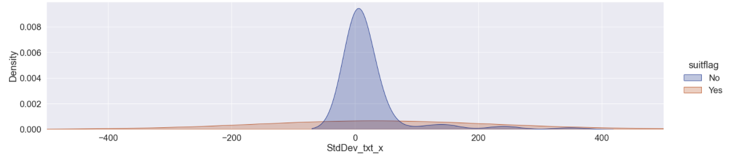

**Figure 9**: Distribution of Companies by StdDev_capx values

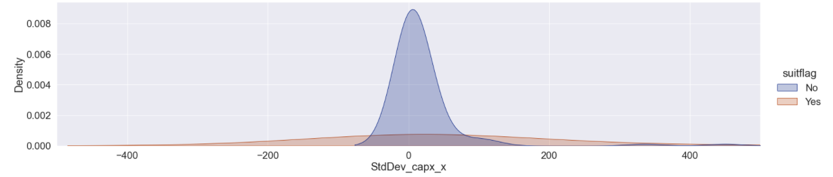

**Figure 8**: Distribution of Companies by Vol_sale_Variance values

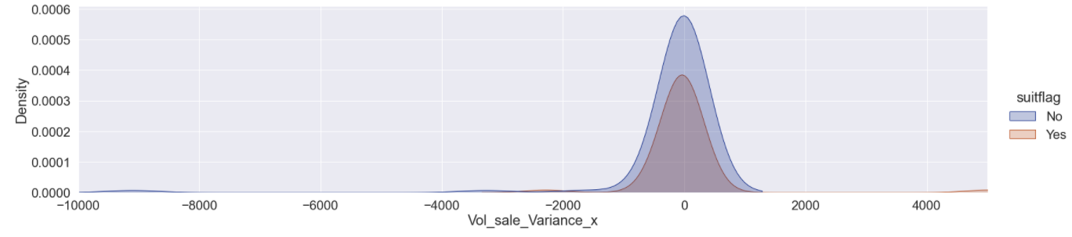

**Severity Risk Assessment**

After setting some parameters in place to determine Crane Co.’s level of risk for a potential shareholder’s suit to occur, the next course of action is to assess the potential severity if a suit were to occur.

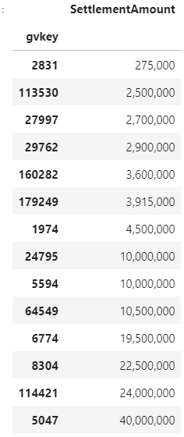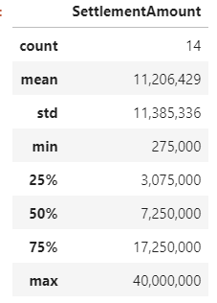

**Figure 11**: Statistical summary of Settlement Amounts in the Industry (left); List of all Settlement Amounts in the Industry (right)

The tables in Figure 11 to the right display both the list of settlement to have occurred in the industry, as well as the statistical summary. There is a wide range of potential outcomes that has occurred, so understanding Crane Co.’s risk strategy or risk tolerance it is willing to accept is key to understanding the amount of insurance it believes is sufficient for the firm to purchase.

As of Crane Co.’s most recent filing, its market capitalization is valued at $5.42 billion. For the purposes of this analysis, focusing on the market capitalization is important, as it is the total measure of shareholder value. Additionally, it is important to take into consideration the relative risk Crane Co. is considering where it stands relative to peers in the previous section of this report. These considerations of Crane Co.’s potential to get sued and its potential exposure will be discussed further in the final section of the report.

The next portion of the analysis will use some of the findings from the model run in conjunction with industry research to assess the level of risk it may to further validate the existing findings in this report.

**Industry Research**

According to Cornerstone Research’s 2021 midyear assessment report on securities class action filings, the semi-annual average number of federal annual shareholder class actions filings in the Industrials industry is 8, while the semi-annual average disclosed loss has risen substantially to $7 billion. The maximum semi-annual dollar loss has been seen upwards of $25 billion (2021). It is important to note the semi-annual average is taken from 1997-2020. For the purposes of this analysis when assessing the potential severity, the numbers provided from Cornerstone Research will be used, as they are most recent and consider the substantial trended increase in dollars paid out for these types of suits.

**Figure 11**: Filings by Industry – Core Federal Filings (2021) – From Cornerstone Class Action Filings 2021 Midyear Assessment

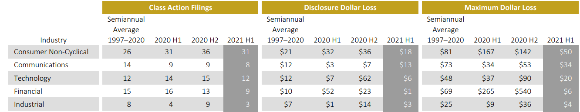

First, this portion of the analysis will look at the industry research and compare the total accuracy of the modeled results of the number of companies predicted to have had a suit filed against them and compare the total to the industry number provided to benchmark and understand validate consistency. The recall of the model predicted 2 of the 24 companies to have a suit filed against them (8%), while the industry research states the annual average of class action filings to be 16. Over the past 4 years, approximately 64 companies of the roughly 576 companies have had suits filed within the industry, this totals out to be 11% of total companies that have been sued.

Second, the analysis assesses the overall severity component of the industry research with the data provided for this analysis. According to industry research the semi-annual average D&O filing is roughly $7 billion. When considering the total market capitalization of Crane Co., a shareholder’s class action suit could be detrimental to the company.

The upcoming section of this report will conclude the results obtained throughout, specifically:

* Assessing the level of risk Crane Co. presents relative to the model’s findings and industry analysis
* Highlighting the model’s findings and limitations
* Providing recommendations for a range of cover Crane Co.’s management should consider

**Assessing Crane Co.’s Relative Risk**

In figures 8, 9 and 10 from the previous section, Crane Co.s position on the distributions amongst its peers and competitors is displayed. Some of the questions when considering the potential likelihood and severity of Crane Co.s being a risk relative to its peers include:

* Where does Crane Co. rank when assessing the volatility of restating its sales?
* Where does Crane Co. rank when assessing both the volatility of reported capital expenditures and income taxes over time?
* Has Crane Co. had a suit filed in the recent past based on the data provided?
* How does industry volume of suits compare to the modeled results to help validate Crane Co.’s likelihood of being a higher risk for a suit to be filed?
* Is Crane Co. in a sub-industry that is more susceptible to the risk of a suit being filed?
* Regarding severity, how much limit may Crane Co. want to consider based on its overall market valuation?

Overall, Crane Co. does not pose as a significant risk relative to its peers, which certainly helps the firm pose a case to ultimately achieve high levels of premium at a somewhat discounted rate. This will be further discussed in the upcoming recommendations portion of this section. However, when considering the industry volume of suits filed, a significant number of companies do face a lawsuit, so although Crane Co. is a lower risk relative to its peers, this is not quite assuring that the firm is safe from a suit occurring.

Although the industry average of losses has been $7 billion from 1997-2020, Crane Co. has a market cap of $5.42 billion. This means Crane Co. have a significant risk for a derivative suit to have a material impact to its overall financial perform.

**Model Limitations**

Although the model output does seem to substantiate that Crane Co. is a relatively lower risk when benchmarked to its peers, it is important to consider the limitations of the model conducted. Below are some of the limitations to consider:

1. The model does contain a limited sample size and is based on historical behavior. Based on this, with limited historical data collected, future behavior has a potential to change significantly in a way the model cannot predict.
2. The model takes into play a wide array of business models throughout the industry, which can make an apples-to-apples comparison more difficult.
3. The model has taken a random sample and although this is unbiased, running additional samples may output different results. This could potentially assess Crane Co. to a different level of risk.

# **Recommendations**

Below is a list of recommendations for Crane Co.’s management to consider based on the analysis presented:

**Model limitations:** Considering the modelling limitations, when considering the additional recommendations below it is important to note that investing additional resources to continue modeling and analyzing Crane Co.’s level of risk a value add to the firm. This recommendation could lead to additional areas of improvement Crane Co. can make to mitigate its risk of a shareholder class action suit.

**Likelihood:** Crane Co.’s initial assessment regarding its likelihood for the risk of a shareholder class action suit to occur displayed positive results when assessing it amongst its peers. However, as a way for management to continue to monitor this risk, it is recommended to create quarterly metrics to measure its volatility in the reported values for the significant variables captured in the model. These metrics include assessing and reviewing swings in:

* The level of reported sales and the process in which these values are reported to mitigate the risks of a significant restated value
* The potential for significant shifts in the amount of reported income taxes and capital expenditures, which may tend to ease investors
* The number of suits occurring in the sub industry in which Crane Co. is in (Industrial Machinery)

Additionally, although these are only a few areas of opportunity picked up by the model, conceptually, it is recommended that management continue to focus on other key financially reported values looking at the process in which values are reported, as well as for significant swings in reported values. Some key financially reported values include number of employees in the firm, net income, cost of goods sold, return on assets, return on equity, etc.

**Severity:** Based on the industry’s volume of filings, as well as the momentum of increasingly severe settlement amount occurring, it is recommended that the firm market themselves out to the industry to create a large directors and officer’s (D&O) tower. Based on the nature of a D&O insurance product and the potentially severe nature of the risk, no one insurer will pay the entire claim if it were to occur. Conducting a broker risk request for proposal (RFP) is recommended. By ensuring you have the best broker for the job, the firm will be in better shape to create a competitive D&O tower at the most reasonable price.

**Final Recommendation:** Although the analytics speak volumes, it is worth explicitly recommending to continuously monitor and improve the firm’s ability to ensure it is clear and transparent to its investors and that all risk factors are clearly stated within the reported financials.

**References**

Cornerstone Research. (2021). *Accounting Class Action Filings 2021 Midyear Assessment*. Cornerstone Research, Inc. https://securities.stanford.edu/research-reports/1996-2021/Securities-Class-Action-Filings-2021-Midyear-Assessment.pdf

**Appendix A – Initial Correlation Plot**

